GRAFANA

Grafana is an open-source visualization and analytics software. No matter where your data is stored, it can be queried, visualized, and explored.

Pros-

1. Display data from wide range of database using visualization tools such as heatmap, histogram and charts.
2. Platform is flexible and easy to use
3. Graphs are interactive
4. Fully Customizable dashboard with customizable alerts and notifications
5. Platform supported- SaaS
6. Easy to switch pattern

Cons-

1. Data Storage and collection must be separately setup

Common Grafana features:

* **Visualize:** Grafana has a plethora of visualization options to help you understand your data from graphs to histograms, you have it all.
* **Alerts:** Grafana lets you define thresholds visually, and get notified via Slack, PagerDuty, and more
* **Unify:** You can bring your data together to get better context. Grafana supports dozens of databases, natively.
* **Open-Source:** It’s completely open source. You can use Grafana Cloud, or easily install on any platform.
* **Explore Logs:** Using label filters you can quickly filter and search through the laundry list of logs.
* **Display dashboards:** Visualize data with templated or custom reports.Create and Share reports:
* **Create and Share reports:** Create and share reports to your customers and stakeholders. This feature is not available in the open-source version. You can upgrade to avail it.

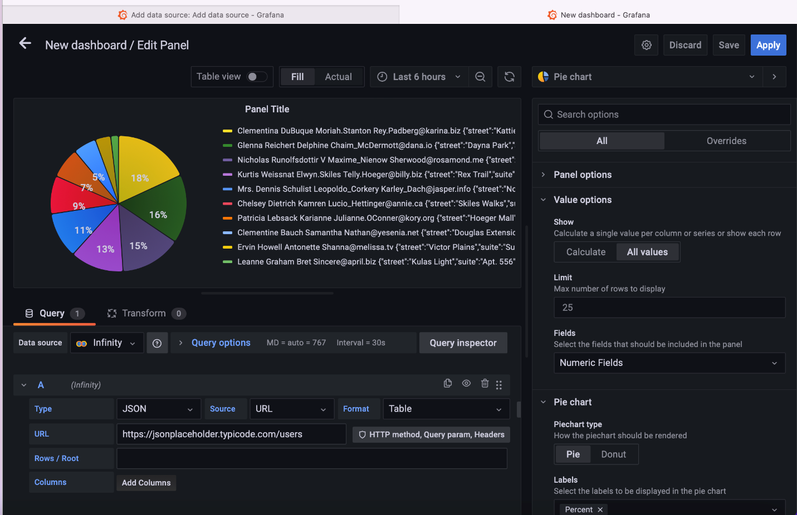

PLOTLY/DASH

Pros-

1. Connects with almost every type of data source like SQL, Excel, etc
2. Charts get saved to repository and are re-used by multiple users.
3. Platform supported- Windows, SaaS
4. User can easily speed up work
5. Customization and flexibility.

Cons-

1. Sometimes fails to visualize extremely large data set.
2. Confusing initial set
3. More code needed

